**Chapter 1**

**Introduction**

Our project is an E-Learning website for online immersive learning experience on a computer or mobile device that is perfect for stimulating a student and encouraging learning.

Admin will be able to manage contents, working system and data of the server/website.

In this website users can view and download various contents available in the web pages. They can also share any desired content.

This system is implemented using html5, CSS, JavaScript, ASP.NET**,** C#. For database SQL server has been used.

**1.1 Background:**

E-Learning, also referred to as Web-based training, is available anywhere, anytime. It is self-paced interactive instruction, presented over the Internet to browser-equipped learners. E-Learning courses span the spectrum from desktop applications to technical certification meeting the needs of today’s life-long learners. The E-Learning solution is empowering, engaging, effective and economical.

E-Learning is easy and engaging. It is available to everyone at any time - all you need is a standard browser like Internet Explorer etc. You do not have to install programs, there are no CDs, it is all done over the Internet and the courses are interactive.

**1.2 Objectives:**

To create an E-learning website or web based learning application so that users can learn and share information about IT and Admin can manage site, perform different operations including that of users.

To make the information and study materials better available for learners.

**1.3 Purpose, Scope and Applicability**

**1.3.1 Purpose**

* To increase access to learning opportunities/increase flexibility for students.
* To enhance the general quality of teaching/learning.
* To meet the learning styles/needs of millennial students.
* To improve the cost-effectiveness of the post-secondary education system
* To digitalize learning.
* To de-institutionalize learning/to enable self-managed learning.
* To embark on a journey of mystery to see where it will take me.

**1.3.2 Scope**

* To develop E-Learning website for Information Technology/Computer Science, so that users can choose the desired content about IT and use it for their benefits. Admin will manage, control database and manage site by uploading, removing and performing other operations to its contents.
* Admin can also add and update various other aspects of the system. Users can see their viewed contents, profile, etc by just logging in into the login panel.

**1.3.3 Applicability**

Though traditional education cannot be replaced, but in this era of fast technological advance and minimization of distance through the use of the Internet, everyone must be equipped with basic knowledge in technology, as well as use it as a medium to reach a particular goal.

* Provides complete web site solution, including site administration.
* All subjects are categorized by course, and all courses are categorized by department.
* Site must be accessed by college student only, after registration administrator must activate the student details. After successful registration student can login into site.
* After successful login student can view his profile, download the subject materials, read contents.
* System has powerful logical access management in place, each user must be identified by login id and strict password policy is applied to secure the system.

**Chapter 2**

**System Planning**

**2.1 Survey of Technologies**

**2.1.1 ASP.NET with C#:**

ASP.NET is a set of Web development tools offered by Microsoft. Programs like Visual Studio .NET and Visual Web Developer allow Web developers to create dynamic websites using a visual interface. ASP.NET also supports Visual Basic.NET, JScript .NET and open-source languages like Python and Perl.

ASP.NET is built on the .NET framework, which provides an application program interface (API) for software programmers. The .NET development tools can be used to create applications for both the Windows operating system and the Web. Programs like Visual Studio .NET provide a visual interface for developers to create their applications, which makes .NET a reasonable choice for designing Web-based interfaces as well.

C# (pronounced "C Sharp") is a programming language developed by Microsoft. It was introduced in 2002 with version 1.0 of Microsoft's .NET Framework. Since then, C# has gone through several revisions, corresponding with each .NET update. Today, it is one of the most popular programming languages for creating Windows programs and web applications.

C# is a derivative of the C programming language and is similar to C++. It uses the same basic operators as C++, is object oriented, case sensitive, and has nearly identical syntax.

# 2.1.2 SQL Server:

SQL Server is Microsoft's relational database management system (RDBMS). It is a full-featured database primarily designed to compete against competitors Oracle Database (DB) and MySQL. Like all major RBDMS, SQL Server supports ANSI SQL, the standard SQL language. However, SQL Server also contains T-SQL, its own SQL implementation. SQL Server Management Studio (SSMS) (previously known as Enterprise Manager) is SQL Server's main interface tool, and it supports 32-bit and 64-bit environments. SQL Server is sometimes referred to as MSSQL and Microsoft SQL Server.

* 1. **Fact-finding Techniques**

**2.2.1 Observations:**

### The method compliments the requisites of the current era where in everyone is racing against time to fetch their share of affluence. Due to the all-inclusive set of advantages, it offers to the learners, eLearning has matured into popular and apprehended way amongst scholars all around the world.

### The process undoubtedly has its limitations. For those with hard economic background and lack of accessibility to technology it is definitely a long shot to exploit its luxury to the fullest. The unprivileged populations of developing countries are saddled with this phase of digital divide.

But with an attempt to make internet more affordable and far reaching, it is possible to bridge the gap between low income community and tech access to dissipate the plight of economic divide.

**2.2.2 Research:**

E-learning is a growing field. Traditionally it has referred to full-scale distance education (elements such as platforms, online classrooms, teaching roles, tutors, multimedia, interactive tools, resources, and computer-supported collaborative learning). Normally it has been practised in higher education and corporate and occupational training convarchars as a part of lifelong learning. However, with the emergence of new open and mobile platforms and web apps, a range of possibilities has opened to facilitate teaching and learning processes in fully on-site or blended environments. As a result, e-learning has been implemented in all educational systems. Technological innovations have led to the development of effective new methods that have been identified in reports on e-learning trends and have been taken to all stages of education. Examples include experiences based on mobile learning, game-based learning, MOOCs, the flipped classroom, and learning analytics, all of which are becoming increasingly visible.

**2.3 Feasibility Study**

A feasibility analysis is used to determine the viability of an idea, such as ensuring a project is legally and technically feasible as well as economically justifiable. It tells us whether a project is worth the investment—in some cases, a project may not be doable. There can be many reasons for this, including requiring too many resources, which not only prevents those resources from performing other tasks but also may cost more than an organization would earn back by taking on a project that isn’t profitable.

### 2.3.1 Technical Feasibility

### This assessment focuses on the technical resources available to the organization. It helps organizations determine whether the technical resources meet capacity and whether the technical team is capable of converting the ideas into working systems. Technical feasibility also involves evaluation of the hardware, software, and other technical requirements of the proposed system.

### 2.3.2 Economic Feasibility

### This assessment typically involves a cost/ benefits analysis of the project, helping organizations determine the viability, cost, and benefits associated with a project before financial resources are allocated. It also serves as an independent project assessment and enhances project credibility—helping decision-makers determine the positive economic benefits to the organization that the proposed project will provide.

### 2.3.3 Operational Feasibility

### Operational feasibility is a measure of how well a proposed system solves the problems, and takes advantage of the opportunities identified during scope definition and how it satisfies the requirements identified in the requirements analysis phase of system development.

**2.4 Stakeholders**

### A stakeholder is any person or entity that has an interest in the success or failure of a business or project. Stakeholders can have a significant impact on decisions regarding the operations and finances of an organization. Examples of stakeholders are creditors, employees, and even the local community. Here is more information about the various categories of stakeholder:

1. Students
2. Teachers
3. Educational institutes

In short, stakeholders can comprise a substantially larger pool of entities than the more traditional group of shareholders who actually own a business.

**Chapter 3**

**Requirement and Analysis**

**3.1 Problem Definition**

Students take down notes from different sources. People buy costly books to study. They had to cover different sites or other sources for latest technology news.

The students as well other users had to rely on physical books, notes and other educational content. For soft documents they have to access as well as had to go through different websites and procedures.

Thus current situation leads to wastage of time as well as efforts during critical situation (ex: Exams...).

Current situation doesn’t have any centralized solution or location for required resources by users.

**3.2 Requirement Specification**

**3.2.1 Functional Requirements**

**User/Admin Registration requirements**

User must be able to register through valid details. On opening the site, user must be prompted to register their email or username. The username will be the unique identifier of his/her account on the site.

* + 1. **Non Functional Requirements/ Software Attributes**
* **Scalability**

Website should be able to provide access to contents and services to as much users as possible at any given time.

* **Privacy**

User’s data should be encrypted to maintain privacy.

* **Performance**

Application must be lightweight and must work smoothly and response instantly.

* 1. **Planning and Scheduling**

**3.3.1 Project Planning**

Project planning (or it is frequently called “Project Management Application Software“ is a computer program that helps people involved in the project management process to initiate, plan, execute, monitor and close projects of any size and type.

Project planning is designed to plan and document project tasks and activities, build schedules and timelines, solve project issues, manage risks and threats, assign budgets and control costs, establish collaboration and cooperation between project participants, assure and control quality, assemble project teams and organize human resources, and share information.

Actually, the list of project planning software capabilities is large enough but the main idea of PP application is to allow you to take your project through all the stages of project life cycle, from project conceptualization and initiation through project execution, control and completion.

The importance of project planning consists in providing you with tools that allow keeping ahead of rivals and continuously working on improvement of tasks, services and processes with very short time-to-market. The best software for project planning significantly helps achieve success in developing, producing and delivering your product allowing combining project activities with cross-functional expertise

**3.3.2 Project Scheduling**

Project scheduling is a mechanism to communicate what tasks need to get done and which organizational resources will be allocated to complete those tasks in what timeframe. A project schedule is a document collecting all the work needed to deliver the project on time. A Gantt chart is a type of bar chart that illustrates a project schedule, named after its inventor, Henry Gantt, who designed such a chart around the years 1910–1915. Modern Gantt charts also show the dependency relationships between activities and current schedule status.

**Gantt chart**

|  |  |  |  |  |  |  |  |  |  |  |  |  |  |  |  |  |  |  |  |  |  |  |  |
| --- | --- | --- | --- | --- | --- | --- | --- | --- | --- | --- | --- | --- | --- | --- | --- | --- | --- | --- | --- | --- | --- | --- | --- |
| Sr no. | TASK | JUNE | | | JULY | | | AUGUST | | | SEPTEMBER | | | OCTOBER | | | NOVEMBER | | | DECEMBER | | |  |
|  |  | 10 | 20 | 30 | 10 | 20 | 30 | 10 | 20 | 30 | 10 | 20 | 30 | 10 | 20 | 30 | 10 | 20 | 30 | 10 | 20 | 30 |  |
| 1. | INTRODUCTION  A)BACKGROUND  B)OBJECTIVE  C)PURPOSE,SCOPE & APPLICABILITY |  | | |  | | |  | | |  | | |  | | |  | | |  | | |  |
| 2. | SYSTEM PLANNING  A)SURVEY of TECHNOLOGY  B) FACT FINDING TECHNIQUE  C) FEASIBILITY STUDY,STOCKHOLDERS |  | | |  | | |  | | |  | | |  | | |  | | |  | | |  |
| 3. | REQUIREMENT & ANALYSIS  A)PROBLEM DEFINITION  B) REQUIREMENT SPECIFICATION  C) PLANNING & SCHEDULING  D) SOFTWARE & HARDWARE REQUIREMENT  E) CONCEPTUAL MODELS |  | | |  | | |  | | |  | | |  | | |  | | |  | | |  |
| 4. | SYSTEM DESIGN  A)BASIC MODULES  B)DATA DESIGN  C)USER INTERFACE DESIGN  D)SECURITY ISSUE  E)TEST CASE DESIGN |  | | |  | | |  | | |  | | |  | | |  | | |  | | |  |

**3.4 Software & Hardware Requirements**

**3.4.1 Interface:**

* This application interacts with the user through G.U.I. The interface is simple, easy to handle and self-explanatory.
* Once opened, user will easily come into the flow with the application and easily uses all interfaces properly.

**3.4.2 Software requirements**

Software’s can be defined as programs which run on our computer .it act as petrol in the vehicle. It provides the relationship between the human and a computer. It is very important to run software to function the computer. Various software are needed in this project for its development.

* Visual Studio 2015
* Google Chrome
* O.S **-**Windows 10

**3.4.3 Hardware requirements**

* **R.A.M** - 4 GB
* **Processor** - Intel I3 2nd Gen
* **System Type** - 64 bit
* **Hard**-**Disk-** 500 GB
* **Frontend-**

HTML5, CSS, JavaScript, ASP .NET

* **Backend-**

SQL**,** C#

**3.5 Conceptual Models**

**E-R Diagram**

The Entity-Relationship (ER) model was originally proposed by Peter in 1976 as a way to unify the network and relational database views. Simply stated the ER model is a conceptual data model that views the real world as entities and relationships. A basic component of the model is the Entity-Relationship diagram which is used to visually represent data objects. Since Chen wrote his paper the model has been extended and today it is commonly used for database design for the database designer, the utility of the ER model is:

* It maps well to the relational model. The constructs used in the ER model can easily be transformed into relational tables.
* It is simple and easy to understand with a minimum of training. Therefore, the model can be used by the database designer to communicate the design to the end user.

In addition, the model can be used as a design plan by the database developer to implement a data model in specific database management software.

* **Entities**, which are represented by rectangles. An entity is an object or concept about which you want to store information. 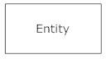 A weak entity is an entity that must defined by a foreign key relationship with another entity as it cannot be uniquely identified by its own attributes alone. 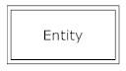
* **Actions**, which are represented by diamond shapes, show how two entities share information in the database. . 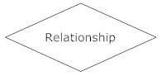
* **Attributes**, which are represented by ovals. A key attribute is the unique, distinguishing characteristic of the entity. For example, an employee's social security number might be the employee's key attribute. 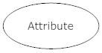
* **Connecting lines**, solid lines that connect attributes to show the relationships of entities in the diagram.

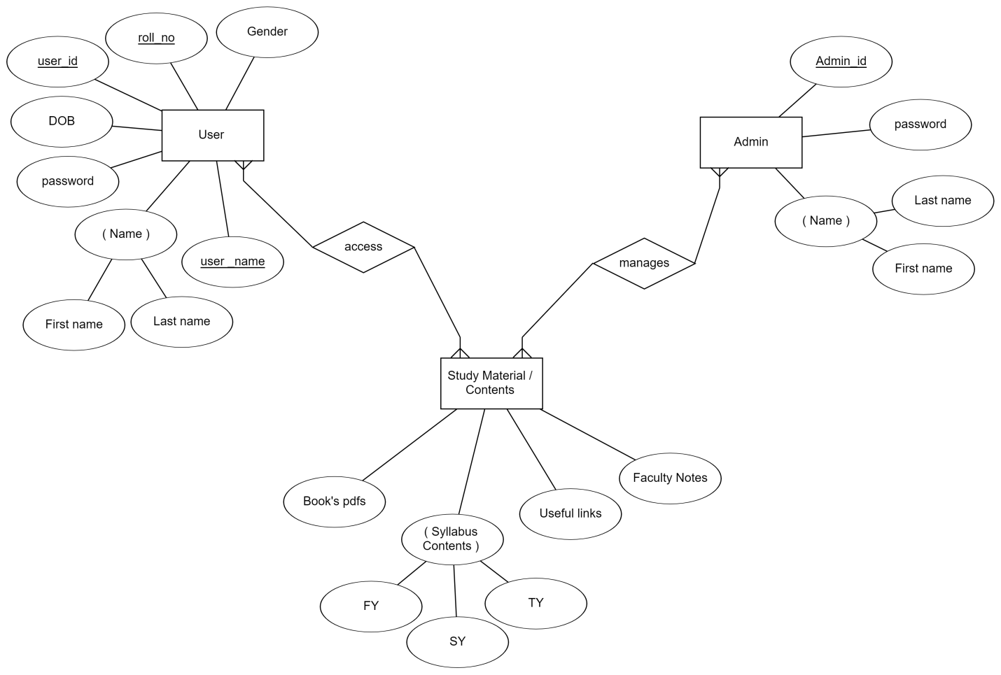

**Activity Diagram**

The focus of activity modelling is the sequence and conditions for coordinating lower-level behaviours, rather than which classifiers own those behaviours.These are commonly called control flow and object flow models.

The behaviours coordinated by these models can be initiated because other behaviours finish executing, because objects and data become available, or because events occur external to the flow.

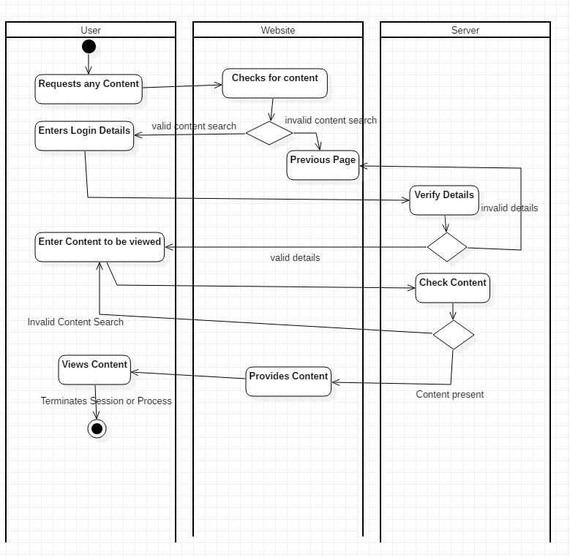

**Use Case Diagram**

A use case diagram is a dynamic or behavior diagram in [UML](https://www.smartdraw.com/uml-diagram/). Use case diagrams model the functionality of a system using actors and use cases. Use cases are a set of actions, services, and functions that the system needs to perform. In this conVarchar, a "system" is something being developed or operated, such as a web site. The "actors" are people or entities operating under defined roles within the system.

**Use Case**

Draw use cases using ovals. Label the ovals with verbs that represent the system's functions.

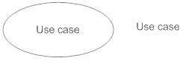

**Actors**

Actors are the users of a system. When one system is the actor of another system, label the actor system with the actor stereotype.

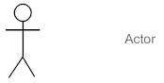

**Relationship**

Illustrate relationships between an actor and a use case with a simple line. For relationships among use cases, use arrows labeled either "uses" or "extends." A "uses" relationship indicates that one use case is needed by another in order to perform a task. An "extends" relationship indicates alternative options under a certain use case.

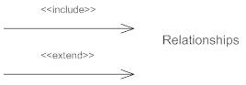

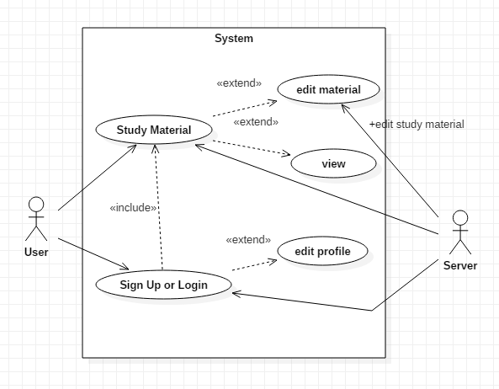

**User Login Sequence Diagram**

A sequence diagram is an interaction diagram that shows how processes operate with one another and in what orders sequence diagram emphasizes on time sequence of messages.

A sequence diagram shows as parallel, vertical lines different processes or objects that live simultaneously and as horizontal arrows, the message exchanged between them in order in which they occur. An important characteristic of a sequence diagram is that time passes from top to bottom.

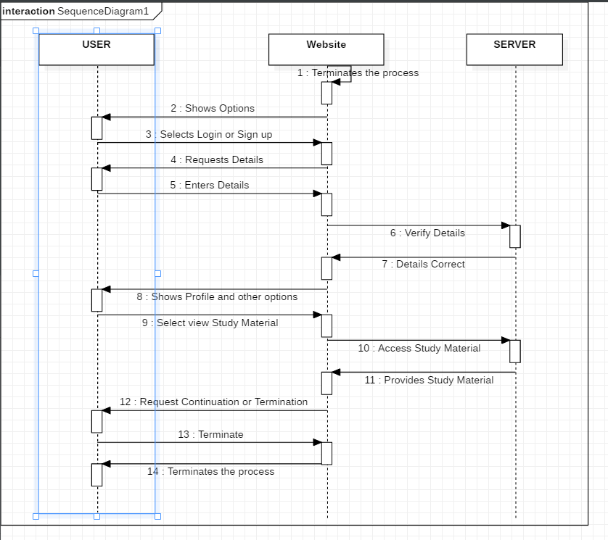

**Class Diagram**

A class diagram models the static structure of a system. It shows relationships between classes, objects, attributes, and operations.

**Classes**

Classes represent an abstraction of entities with common characteristics. Associations represent the relationships between classes.

Illustrate classes with rectangles divided into compartments. Place the name of the class in the first partition (centered, bolded, and capitalized), list the attributes in the second partition (left-aligned, not bolded, and lowercase), and write operations into the third.

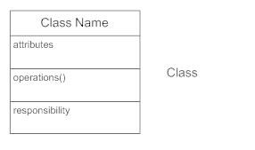

**Active Classes**

Active classes initiate and control the flow of activity, while passive classes store data and serve other classes. Illustrate active classes with a thicker border.

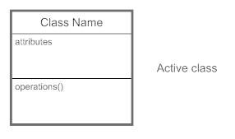

**Associations**

Associations represent static relationships between classes. Place association names above, on, or below the association line. Use a filled arrow to indicate the direction of the relationship. Place roles near the end of an association. Roles represent the way the two classes see each other.

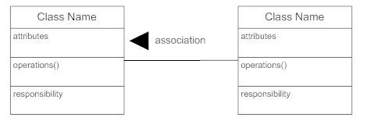

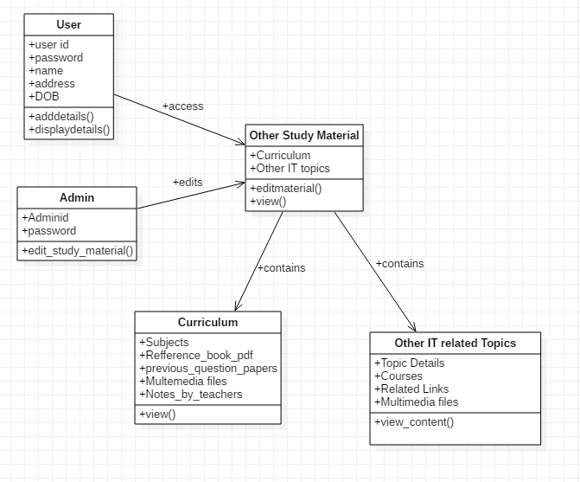

**Collaboration Diagram:**

A collaboration diagram, also known as a communication diagram, is an illustration of the relationships and interactions among software [objects](https://searchmicroservices.techtarget.com/definition/object) in the Unified Modeling Language ([UML](https://searchsoftwarequality.techtarget.com/definition/Unified-Modeling-Language)). These diagrams can be used to portray the dynamic behavior of a particular [use case](https://searchsoftwarequality.techtarget.com/definition/use-case/) and define the role of each object.

Collaboration diagrams are created by first identifying the structural elements required to carry out the functionality of an interaction. A model is then built using the relationships between those elements. Several vendors offer software for creating and editing collaboration diagrams.

### Notations of a collaboration diagram

A collaboration diagram resembles a [flowchart](https://whatis.techtarget.com/definition/flowchart) that portrays the roles, functionality and behavior of individual objects as well as the overall operation of the system in [real time](https://whatis.techtarget.com/definition/real-time). The four major components of a collaboration diagram are:

1. Objects- Objects are shown as rectangles with naming labels inside. The naming label follows the convention of object name: class name. If an object has a property or state that specifically influences the collaboration, this should also be noted.
2. Actors- Actors are instances that invoke the interaction in the diagram. Each actor has a name and a role, with one actor initiating the entire use case.
3. Links- Links connect objects with actors and are depicted using a solid line between two elements. Each link is an instance where messages can be sent.
4. [Messages](https://whatis.techtarget.com/definition/message)- Messages between objects are shown as a labeled arrow placed near a link. These messages are communications between objects that convey information about the activity and can include the sequence number.

The most important objects are placed in the center of the diagram, with all other participating objects branching off. After all objects are placed, links and messages should be added in between.

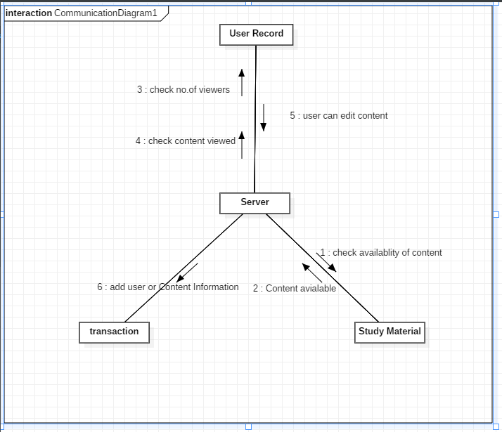

**Deployment Diagram**

A deployment diagram is a UML diagram type that shows the execution architecture of a system, including nodes such as hardware or software execution environments, and the middleware connecting them.

Deployment diagrams are typically used to visualize the physical hardware and software of a system. Using it you can understand how the system will be physically deployed on the hardware.

Deployment diagrams help model the hardware topology of a system compared to other UML diagram types which mostly outline the logical components of a system.

**Deployment Diagram Notations**

In order to draw a deployment diagram, you need to first become familiar with the following deployment diagram notations and deployment diagram elements.

Node:A node, represented as a cube, is a physical entity that executes one or more components, subsystems or executables. A node could be a hardware or software element.

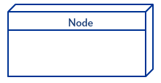

Artifacts: Artifacts are concrete elements that are caused by a development process. Examples of artifacts are libraries, archives, configuration files, executable files etc.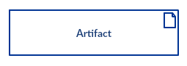

#### Communication Association: This is represented by a solid line between two nodes. It shows the path of communication between nodes.

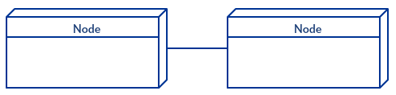

#### Devices: A device is a node that is used to represent a physical computational resource in a system. An example of a device is an application server.

#### Device

#### Deployment Specifications: A deployment specification is a configuration file, such as a Varchar file or an XML document. It describes how an artifact is deployed on a node.

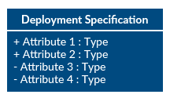

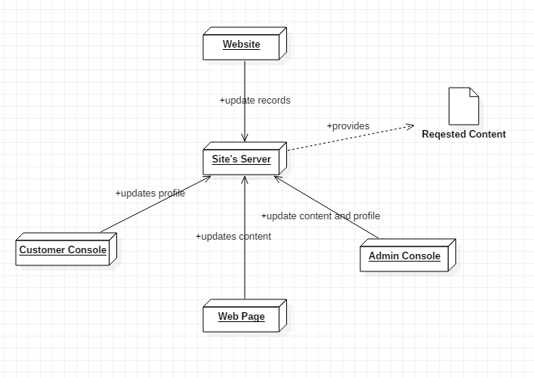

**System Flow chart Diagram:**

A flowchart is a diagram that depicts a process, system or computer algorithm. They are widely used in multiple fields to document, study, plan, improve and communicate often complex processes in clear, easy-to-understand diagrams

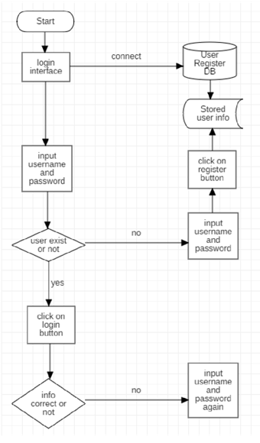

**Chapter 4**

**System Design**

**4.1 Basic Modules:**

The system comprises of 2 major modules with their sub-modules as follows:

1. **User / Student**

* Login: User can login his account using id and password.
* Main Menu: User will have access of main menu.
* Upload: User can submit for consideration of upload any document.
* Knowledge: User read the uploaded knowledge articles, study materials.

1. **Admin**

* Login: Admin can login using credentials.
* Manage User: Admin can manage users.
* Editing: Admin can add, update, access and delete contents.

1. **Contents**

* Books
* Pdfs
* Links
* Videos
* Notes
* Question Papers

**4.2 Data Integrity and constraints**

**Table name:** registration

**Description:** It contains registration information of User.

|  |  |  |  |  |
| --- | --- | --- | --- | --- |
| **Field** | **Data type** | **Size** | **Constraint** | **Description** |
| first-name | Varchar | 30 |  | User’s First Name |
| last-name | Varchar | 30 |  | User’s Last Name |
| gender | Varchar | 10 |  | User’s Gender |
| username | Varchar | 30 | Primary Key | User’s Username |
| password | Varchar | 30 |  | User’s Password |
| user_id | Varchar | 30 |  | User’s ID |

**Table name:** Admin

**Description:** It contains information of username and password.

|  |  |  |  |  |  |
| --- | --- | --- | --- | --- | --- |
| **Field** | **Data type** | **Size** | **Constraint** | **Description** |  |
|  |  |  |  |  |  |
|  |  |  |  | Keeps the |  |
| admin_name | Varchar | 50 | Foreign key | username of User |  |
|  |  |  |  |  |  |
| password | Varchar | 50 |  | Keeps the  password of User |  |
|  |
| admin_id | Varchar | 50 |  | Stores the admin id |  |

**Table name:** content

**Description:** It contains information of content’s type, name, id.

|  |  |  |  |  |  |
| --- | --- | --- | --- | --- | --- |
| **Field** | **Data type** | **Size** | **Constraint** | **Description** |  |
| Conten_type | Varchar | 50 |  | Saves type of content |  |
| Content_name | Varchar | 50 |  | Stores content name |  |
| Conten_id | Varchar | 50 | Foreign key | username of |  |

**4.3 User Interface Design**

**Home Page:**

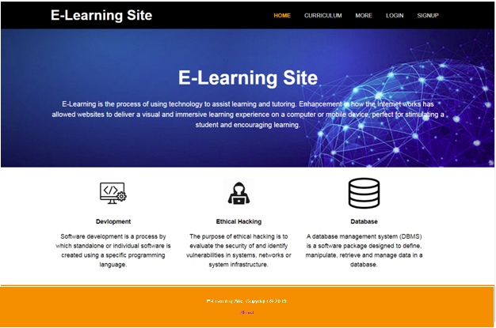

**Login Page:**

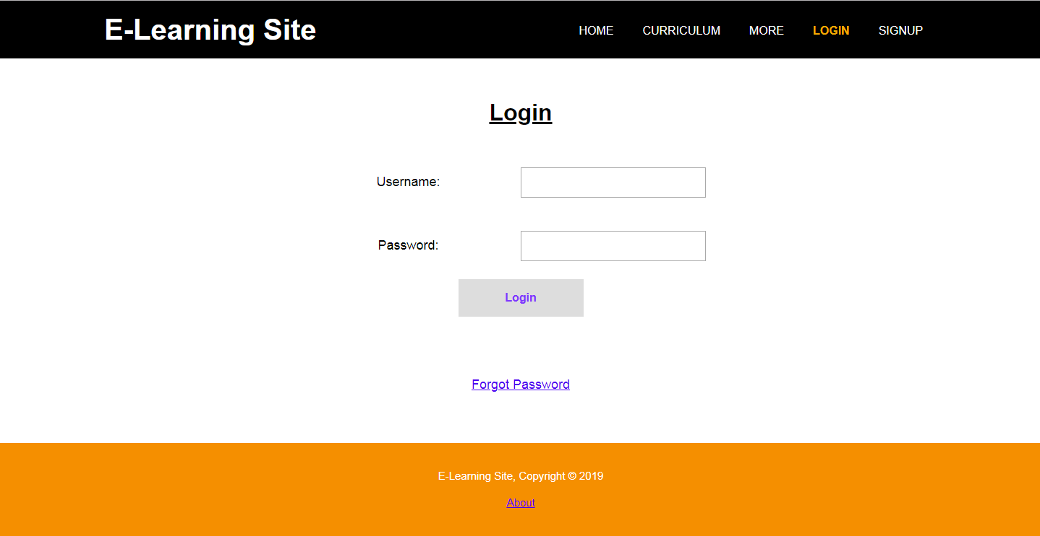

**Sign Up Page:**

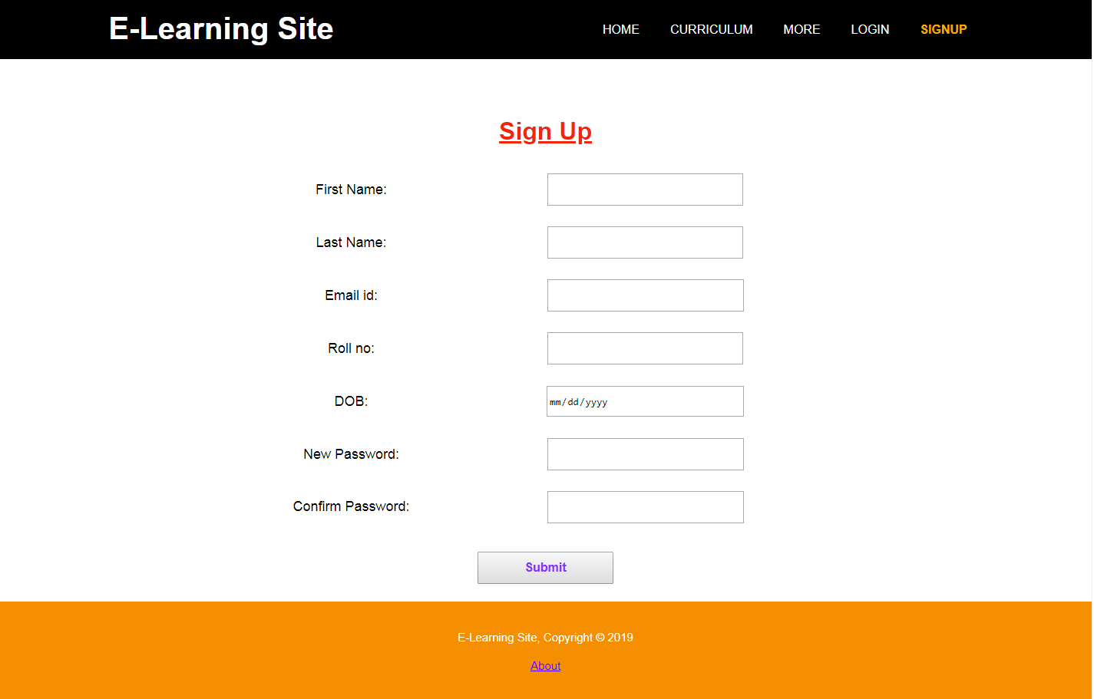

**Forgot Password:**

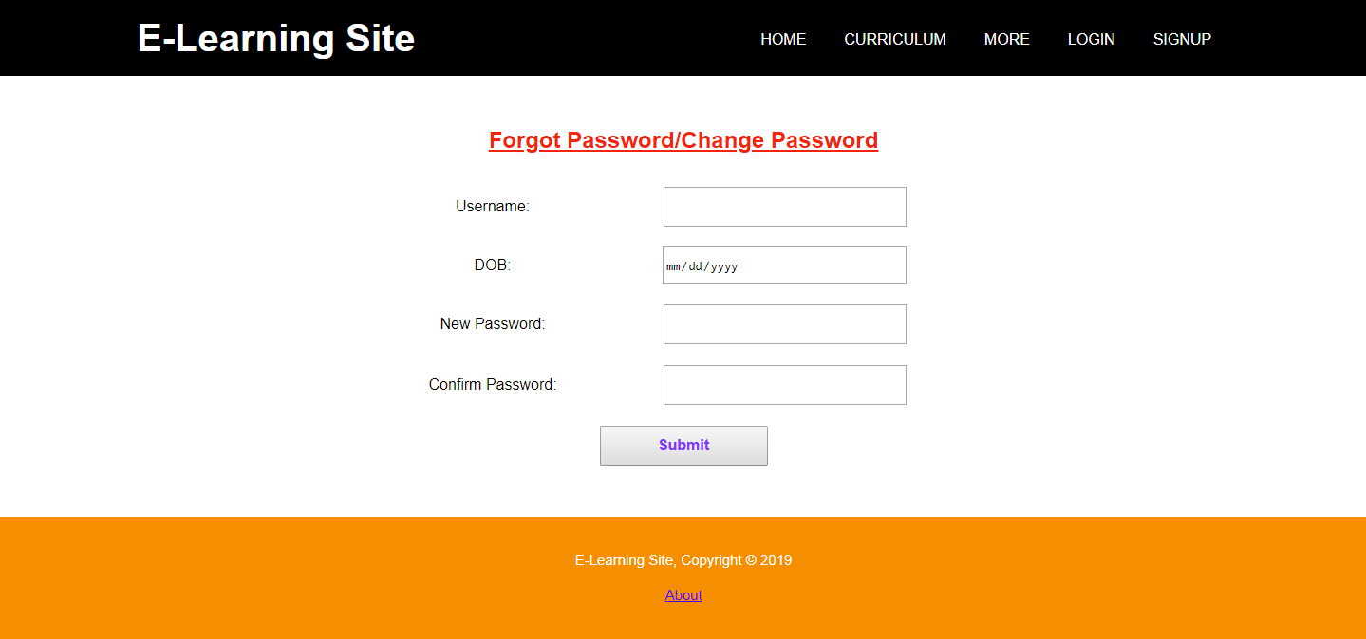

**4.4 Security issue**

E-learning security plays a very important role in e-learning systems development despite its huge benefits. There are numerous challenges faced by learners, Higher learning Institutions and e-learning service providers in today’s internet age. Some of these challenges include:

1. **Interoperability of applications:**

Despite current technological advances in e-learning, emerging trends are demanding a greater level of interoperability for components, systems, applications, and environments which are often developed for a particular institutions or organization and provide very similar functionalities (Cardenas and Sanchez, 2005).

1. **Standardization and compatibility:**

These are vital for both e-learning service providers and end users (learners) to be able to inter-change components in the market. These are very important where different e-learning systems must interact with one another.

1. **Security policy and enforcement Mechanism:**

The security policy is defined as the set of laws, rules and practices that regulate how an organization manages, protects and distributes sensitive information. Once the security policy is defined, it must be captured and followed at application runtime via enforcement mechanism which represents the set of centralized and distribute software to ensure that the security policy is maintained and never violated.

1. **E-learning Infrastructure:**

This refers to Hardware, Software and connectivity required for e-learning development and implementation (Taurus et al., 2015).

**Possible attacks on e-learning system and countermeasures**

1. **Availability attack:**

This is an attack that occurs when services of a system and contents are unavailable to legitimate users for some time. Examples of such attacks include Denial of Service, Node attacks, Line Adetoba et al. 98 attacks, Network infrastructure attacks. A Good backup system is a way of countering these attacks.

1. **Integrity attack:**

This aims to destroy or modify the contents of the system. Due to the integrity attack, the legitimate users will not get the correct contents; examples are malicious code attacks, message injection, traffic modification, traffic deletion. To counter integrity attacks, digital signature, data hashing and shining can be used effectively. Authorization should be strong enough to keep unauthorized users at bay to stop them from many chances to alter the information. Protocols should be tempered resistant across communication links.

1. **Confidentiality attack:**

This attack tries to expose the confidential data to unauthorized users. This may be transfer of e-contents to the unauthorized persons or obtaining secret passwords; example includes: Group session eavesdropping, Group session traffic analysis, and Group identity disclosure. Strong encryption methods should to be used to counter confidentiality attack.

1. **Authentication attack:**

The attack is to gain access to system information by using stolen passwords, key or credentials or an attack device pretending as legitimate device trying to gain access to the system. These types of attacks may lead to unauthorized modification of contents and breach of confidentiality, examples includes brute force attack, dictionary attack, login spoofing attacks, key management attacks, replay attacks, Man-in-middle attacks. To counter these attacks, strong authentication method such as Biometric based security should be considered.

1. **Authorization attacks:**

An attack that occurs as a result of unauthorised access to specific content. Unauthorized use or elevation of access can be countered by using the principle of least privilege; strong access control lists (ACL’s) or Strong role based security mechanism should be used.

1. **Countering non-Repudiation:**

To counter the problem of non-repudiation, digital signature can be used and Audit trails should be created.

**4.5 Test Case Designs**

System testing is a critical aspect of Software Quality Assurance and represents the ultimate review of specification, design and coding. Testing is a process of executing a program with the intent of finding an error.

A good test is one that has a probability of finding a yet undiscovered error. The purpose of testing is to identify and correct bugs in the developed system. Nothing is complete without testing. Testing is vital in the success of the system.

In the code testing the logic of the developed system is tested. For this every module of the program is executed to find an error. To perform specification test, the examination of the specifications stating what the program should do and how it should perform under various conditions.

|  |  |  |
| --- | --- | --- |
|  | **RESULT** | **EXAMPLES** |
| Character | Not accepted | aDgf.. |
| Invalid number | Not accepted | 1,2,3.. |
| First digit | Accepted | 7,8,9.. |
| More than(10 digit) | Not accepted | 9045675612982 |
| Valid no.(10) | Accepted | 8642193282 |
| Special character | Not accepted | @,#,!... |

|  |  |  |
| --- | --- | --- |
| **Email_id** | **Result** | **Examples** |
| Character | Not accepted | abcmail.com |
| Without domain name | Not accepted | xyzgmail@z |
| Fields with 2 @ | Not accepted | m@nogmai@l |
| Correct email_id | Accepted | email@gmail.com |

|  |  |  |  |  |  |  |  |  |  |  |  |
| --- | --- | --- | --- | --- | --- | --- | --- | --- | --- | --- | --- |
| **Test id** | **Test Cases** | | | **Test Data** | **Actual** | **Expected** | | **Status** | | |  |
|  | **Login** |  |  | | | | | | | |  |
| **1** | Open Login page  Enter username  Enter Password  Click login | | | user  123 | Open Or  Invalid username and password page | Open Or  Invalid username and password page | | Pass | | |  |
|  | **Registration** | | | | | | | | | |  |
| 1 | Enter  registration  details  Click submit | | | Valid details | User  registered |  | User  registered | | | Pass | |
|  |
|  |
|  |
| **2** | Enter  registration  details  Click submit | | | Invalid details | User  registered | Try again | | | Fail | |  |
|  |  | |  |
|  |  | |  |
|  |  | |  |
| **3** | User Login  Enter Username  Enter Password  Click Login | | | XYZ  XYZ@1 | Open Home  Page Or  Invalid  username  &  password | Open Home  Page Or  Invalid  username &  password  page | | | Pass  Fail | |  |
|  |  |
|  |  |
|  |  |
|  |  |
|  |  |
|  |  |